

January 7, 2014

Re: NPA 628 to Overlay NPA 415 (California)

Dear Customer,

On December 19, 2013 the California Public Utilities Commission (CPUC) in Decision 13-12-
055 approved an all-services overlay as the relief method for the 415 NPA. The 415 NPA
generally covers the County of San Francisco, most of Marin County and a small portion of San
Mateo County; serving the communities of Belvedere, Brisbane, Corte Madera, Daly City, Fairfax,
Ignacio, Inverness, Larkspur, Mill Valley, Nicasio, Novato, Point Reyes, Ross, San Anselmo, San
Francisco, San Rafael, Sausalito, Stinson Beach and Tiburon. The new 628 NPA will serve the same
geographic area currently served by the existing 415 NPA.

Implementation of Relief Plan
Implementation of the overlay of the 628 NPA is as follows:

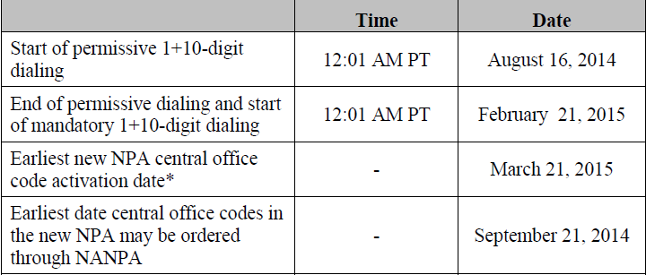
* Effective Date of the New 628 NPA

During the permissive dialing period, subscribers may dial calls within the overlay area on either
a 7-digit or 1+10-digit basis, but will be encouraged to dial 1+10-digits. After the permissive
period ends, all calls must be dialed using 1+10-digits.

PHASE I
Permissive Dialing Date –Began August 16, 2014: During the permissive dialing period, subscribers may dial local calls within the overlay area on either a 7-digit or 10-digit basis, but will be encouraged to dial 10-digits. After the permissive period ends, all calls must be dialed using 10-digits.
When preparing for overlay area code relief, carriers are strongly encouraged to prepare their switches to begin sending 10 digits prior to the mandatory 10-digit dialing conversion date for customers.

PHASE II
Mandatory 10 Digit Dialing Date – Begins February 21, 2015: All callers must dial local calls with 10 digits. If you inadvertently dial 7 digits, your call will not be completed and a recording will prompt you to hang up and dial again.

Dialing Plan
Coincident with the introduction of mandatory 1+10-digit dialing on February 21, 2015, the
dialing plan for the 415 and 628 NPAs will be as follows:

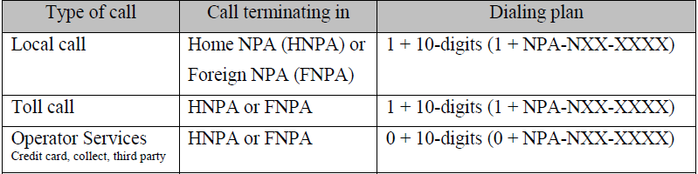

To prepare for this overlay, please note the following:

- Notify your clients, vendors, domestic and international of your new area code.
- Inform employees, customers, and co-workers.
- Changes in telephone equipment should be directed to the equipment vendor.
- Utilize the applicable test number to make sure your equipment recognizes the new area code.
- Update all correspondence, such as stationery, business cards, checks, brochures, promotional items, internet web pages, catalogs, directory listings.
- Reprogram features such as Auto-Dialing, Speed dialing, and Call Forwarding.
- Reprogram security doors and gate systems.
- Contact your service provider to update your cell phone and other wireless communications.
- Internet dial-up connection may need reprogramming or upgraded.
- Notify Alarm system providers of the new area code + telephone number so they can update their records and equipment as needed.

The area code overlay will not affect the cost of a call. Costs incurred for updating systems and revising printed materials is the responsibility of the customer. The directory listings (white pages) will be updated by the telecommunications industry. Listings appearing in other directories will be the responsibility of the customer.

If you have any additional questions, please contact your Premier Specialist or Customer Service 1-866-847-5500.

